**DAILY ONLINE ACTIVITIES SUMMARY**

|  |  |  |  |
| --- | --- | --- | --- |
| **Date:** | 2/07/2020 | **Name:** | Krishnitha |
| **Sem & Sec** | 4th sem, A Section | **USN:** | 4AL18CS039 |
| **Online Test Summary** | | | |
| **Subject** | NA | | |
| **Max. Marks** | NA | **Score** | NA |
| **Certification Course Summary** | | | |
| **Course** | Cloud Support Engineer | | |
| **Certificate Provider** | AWS Educate | **Duration:** | 3 hrs |
| **Coding Challenges** | | | |
| **Problem Statement:**  Write a Java Program minimize the maximum difference between adjacent elements in an array | | | |
| **Status:** Executed | | | |
| **Uploaded the report in GitHub** | | YES | |
| **If yes Repository name** | | <https://github.com/krishnitha/Java-coding> | |
| **Uploaded the report in slack** | | YES | |

**Certification Course Details:**

Today I have continued the course “Cloud Support Engineer” by AWS Educate. In this course today I learnt about ‘Security’. Today I have completed one module of this course, And I have also completed the final assessment and final project of this course. Also I have received a Badge for completion of this course.



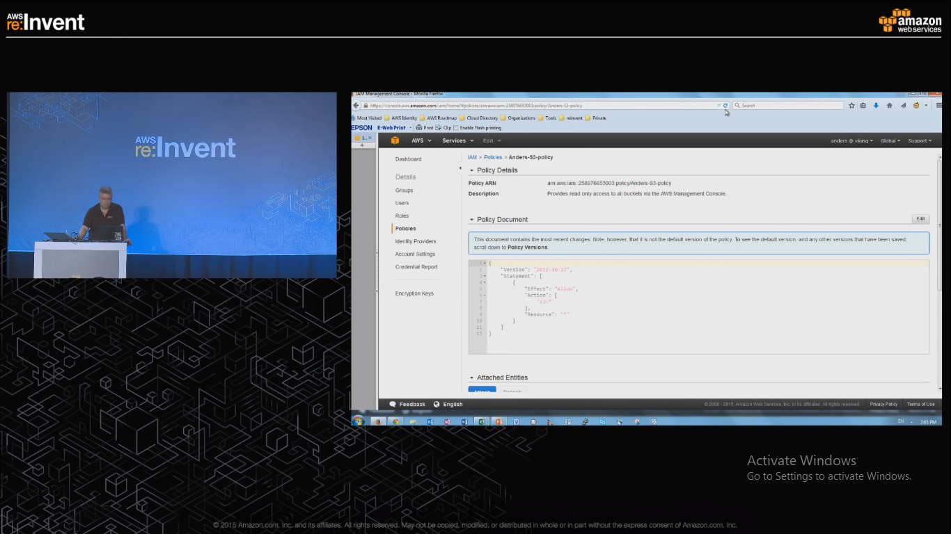



**Webinar Details:**

Today I attended a webinar on “Constructor Destructor, Inheritance, Polymorphism” by Assistant professor Ms. Shruthi Shetty J. The session was very interesting. There was an quiz conducted based on the webinar, I scored 20/30.

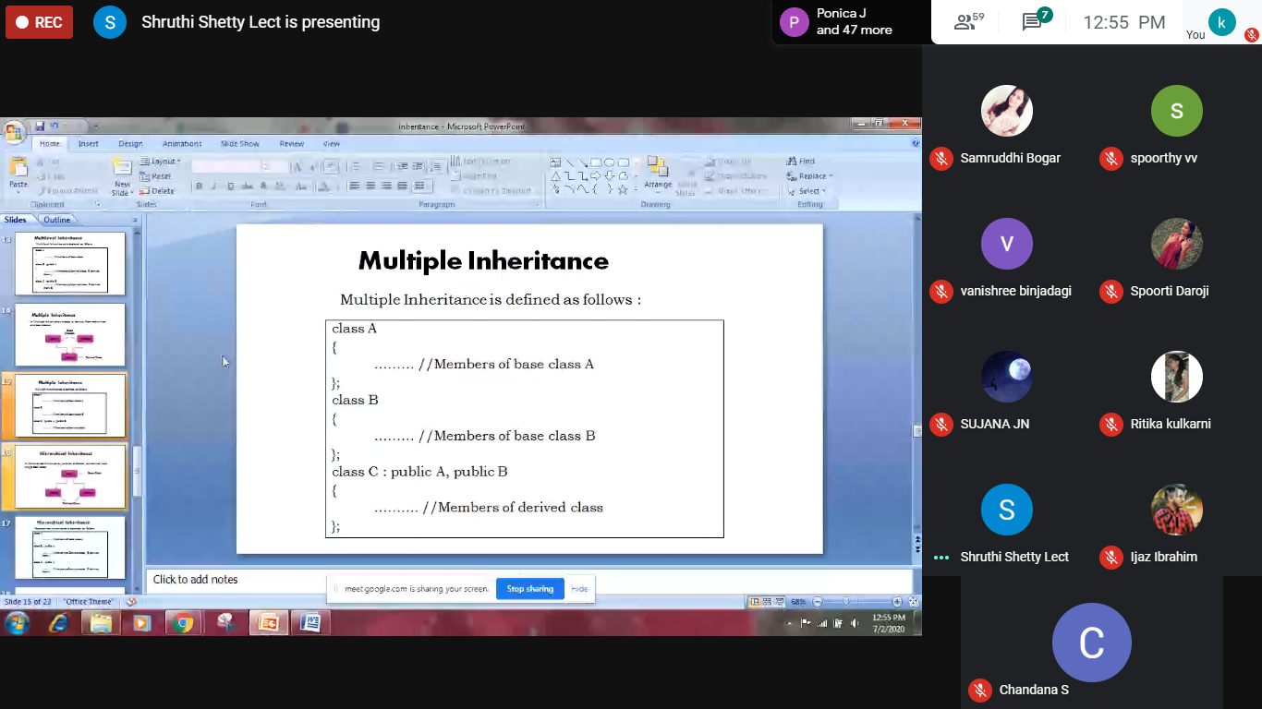

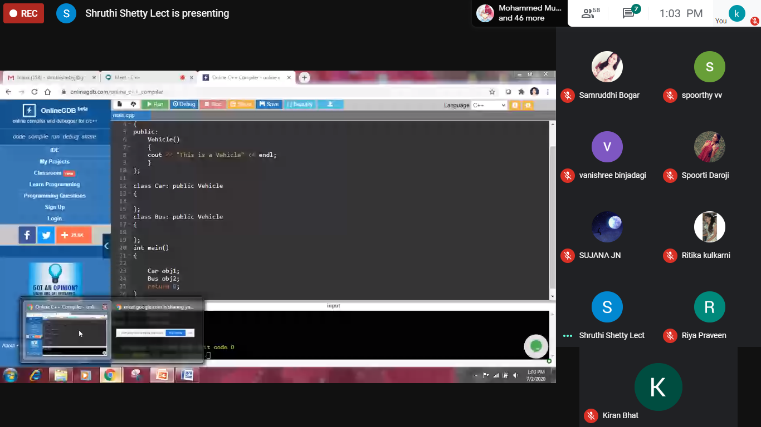

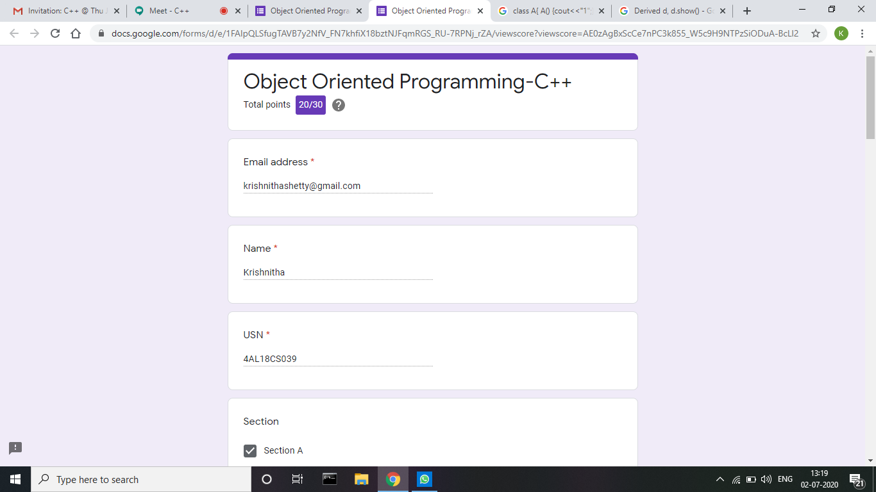

**Coding Challenges Details:**

**Problem:** Write a Java Program minimize the maximum difference between adjacent elements in an array

Given a non-decreasing array arr[] and an integer K, the task is to remove K elements from the array such that maximum difference between adjacent element is minimum.

Note: K < N – 2

**Examples:**

Input: arr[] = {3, 7, 8, 10, 14}, K = 2  
Output: 2

Explanation:  
After removing elements A[0] and A[4],  
The maximum difference between adjacent elements is minimum.  
After removing elements, the remaining array is [7, 8, 10]

**Solution:** Uploaded it in GitHub

